Music215A: Computer Music Composition & Production

Christopher Dobrian, Winter 2018

Final Project: Musical use of surround sound and inter-application communication

Kyungwoo Hyun [kyungwoh@uci.edu](mailto:kyungwoh@uci.edu) (ID: 39324813)

1. Concept

For the final project, I made a conceptual “drum room” in the 3-dimension space. In this virtual space, I can move two spheres with a mouse, and they interact with their environment and user behavior. They dynamically generate 3-dimensional sound with different velocity, stereo panning, and a reverb effect.

1. Environment
   1. DAWs

I used Max 7 as a primary device and Reason 10 as a secondary device. They are connected by ReWire technology and transfer MIDI signals as Propellerhead’s Reason 10 MIDI implementation manual of controller chart.

* 1. 3D graphics

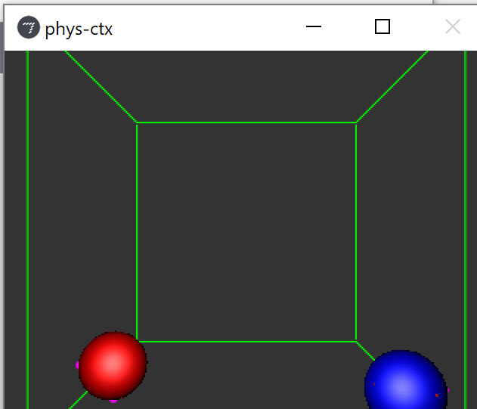

I used OpenGL physics engine, provided by Max 7 OpenGL Jitter API. It simulates gravity movement and collision of entities. I designated Casaba percussion as a red sphere, and Synch tom as a blue sphere. I can hold spheres and draw them into the space as the physics engine rules.

1. Music
   1. Instruments

I used a bass guitar, a bass drum, a cabasa, and a synth drum. Among them, the bass guitar and the bass drum repeats the main part.

* 1. Interactions

As a user move the spheres, percussions’ sound dynamically change like the below.

X-axis: stereo panning (left to right)

Y-axis: velocity (light to strong)

Z-axis: FX send (reverb intensity)